Project-2

Docker:
- Dockerize the application by creating Dockerfile
- Build an application and check output using docker image.

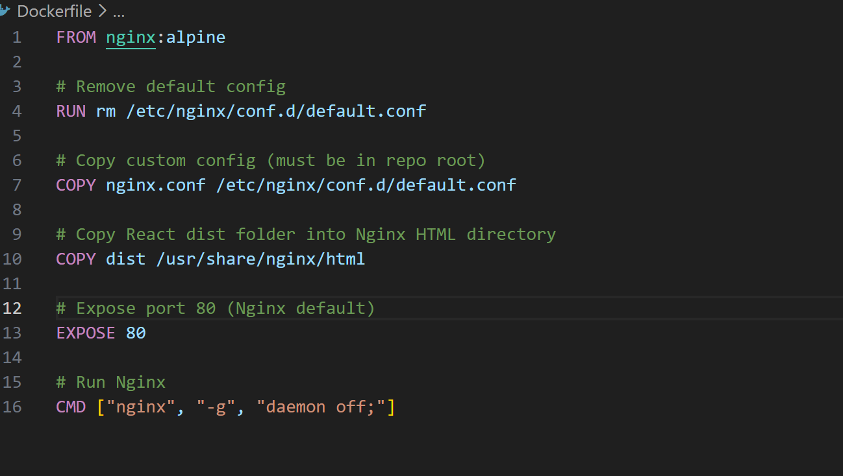



Terraform:
- Define infrastructure in main.tf to create VPC, IAM, EC2 with Jenkins, etc.
- Use terraform command to provision infrastructure.
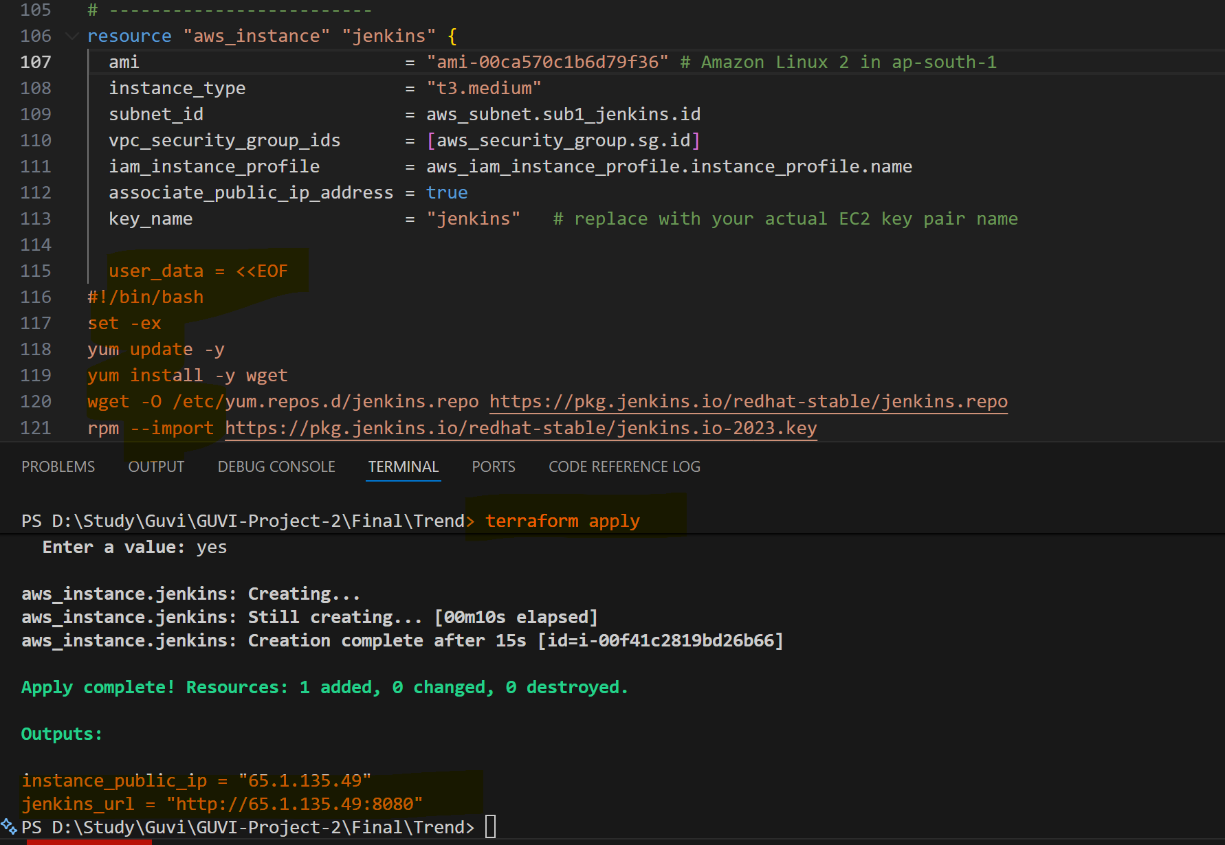

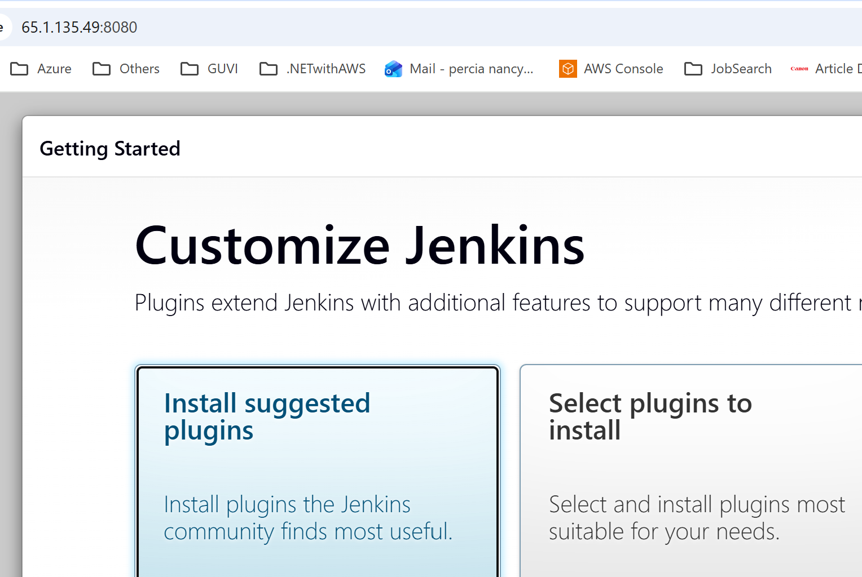

DockerHub:
- Create a DockerHub repository.

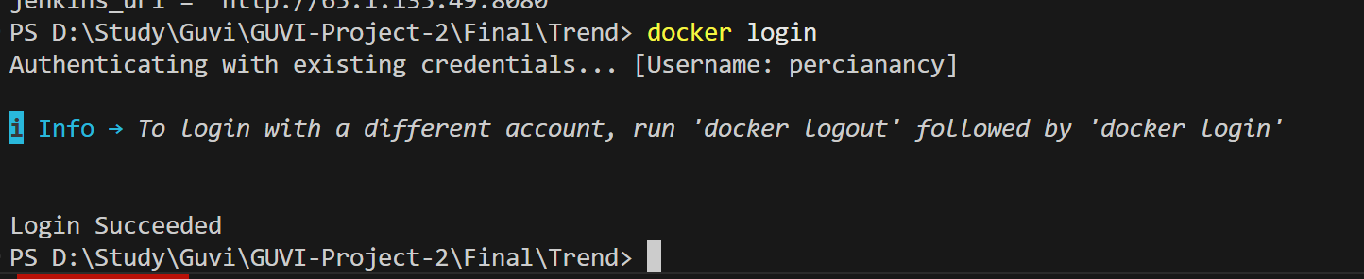
Ran below commands to push to docker hub
docker tag trend-app:latest percianancy/trend-app:latest
docker push percianancy/trend-app:latest
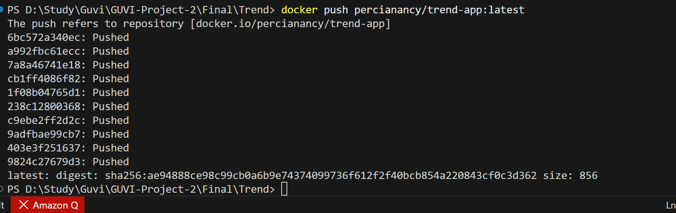

Kubernetes:
- Setup Kubernetes in AWS EKS and Confirm EKS cluster is running.
- Write deployment and service YAML files.
- Deploy using kubectl via Jenkins.

eksctl create cluster --name project2-cluster --region ap-south-1 --nodes 2

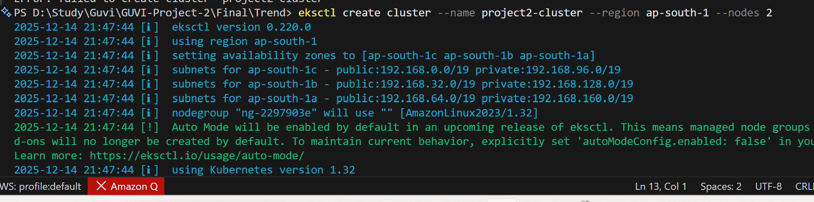
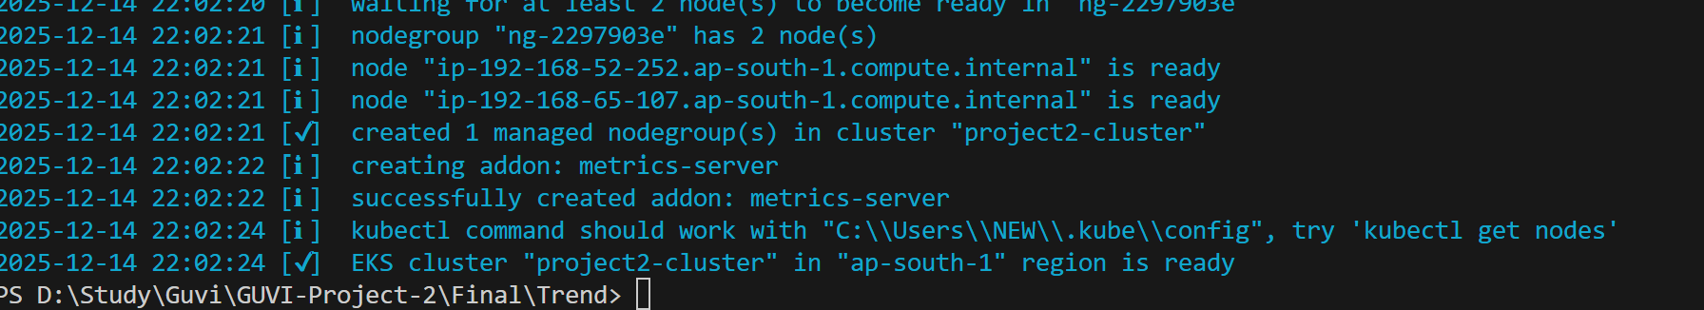

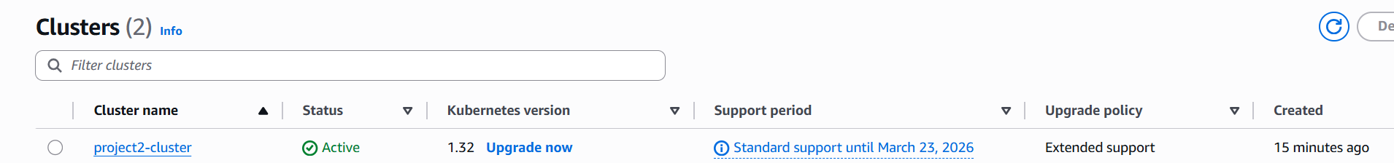
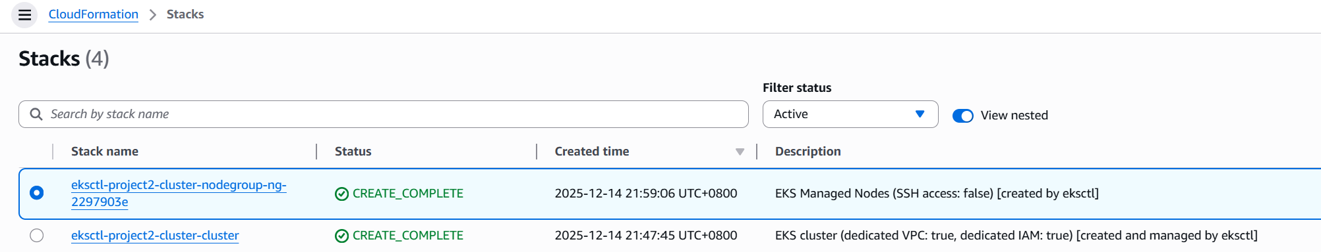

Version Control:
- Push the codebase to a Git provider (GitHub).
- Add gitignore and dockerignore files and use CLI commands to push code.

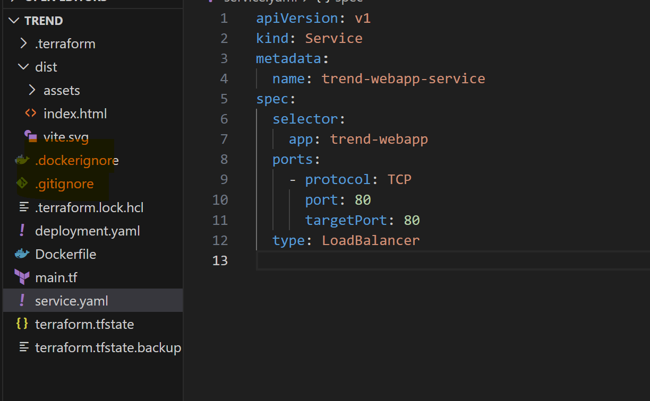

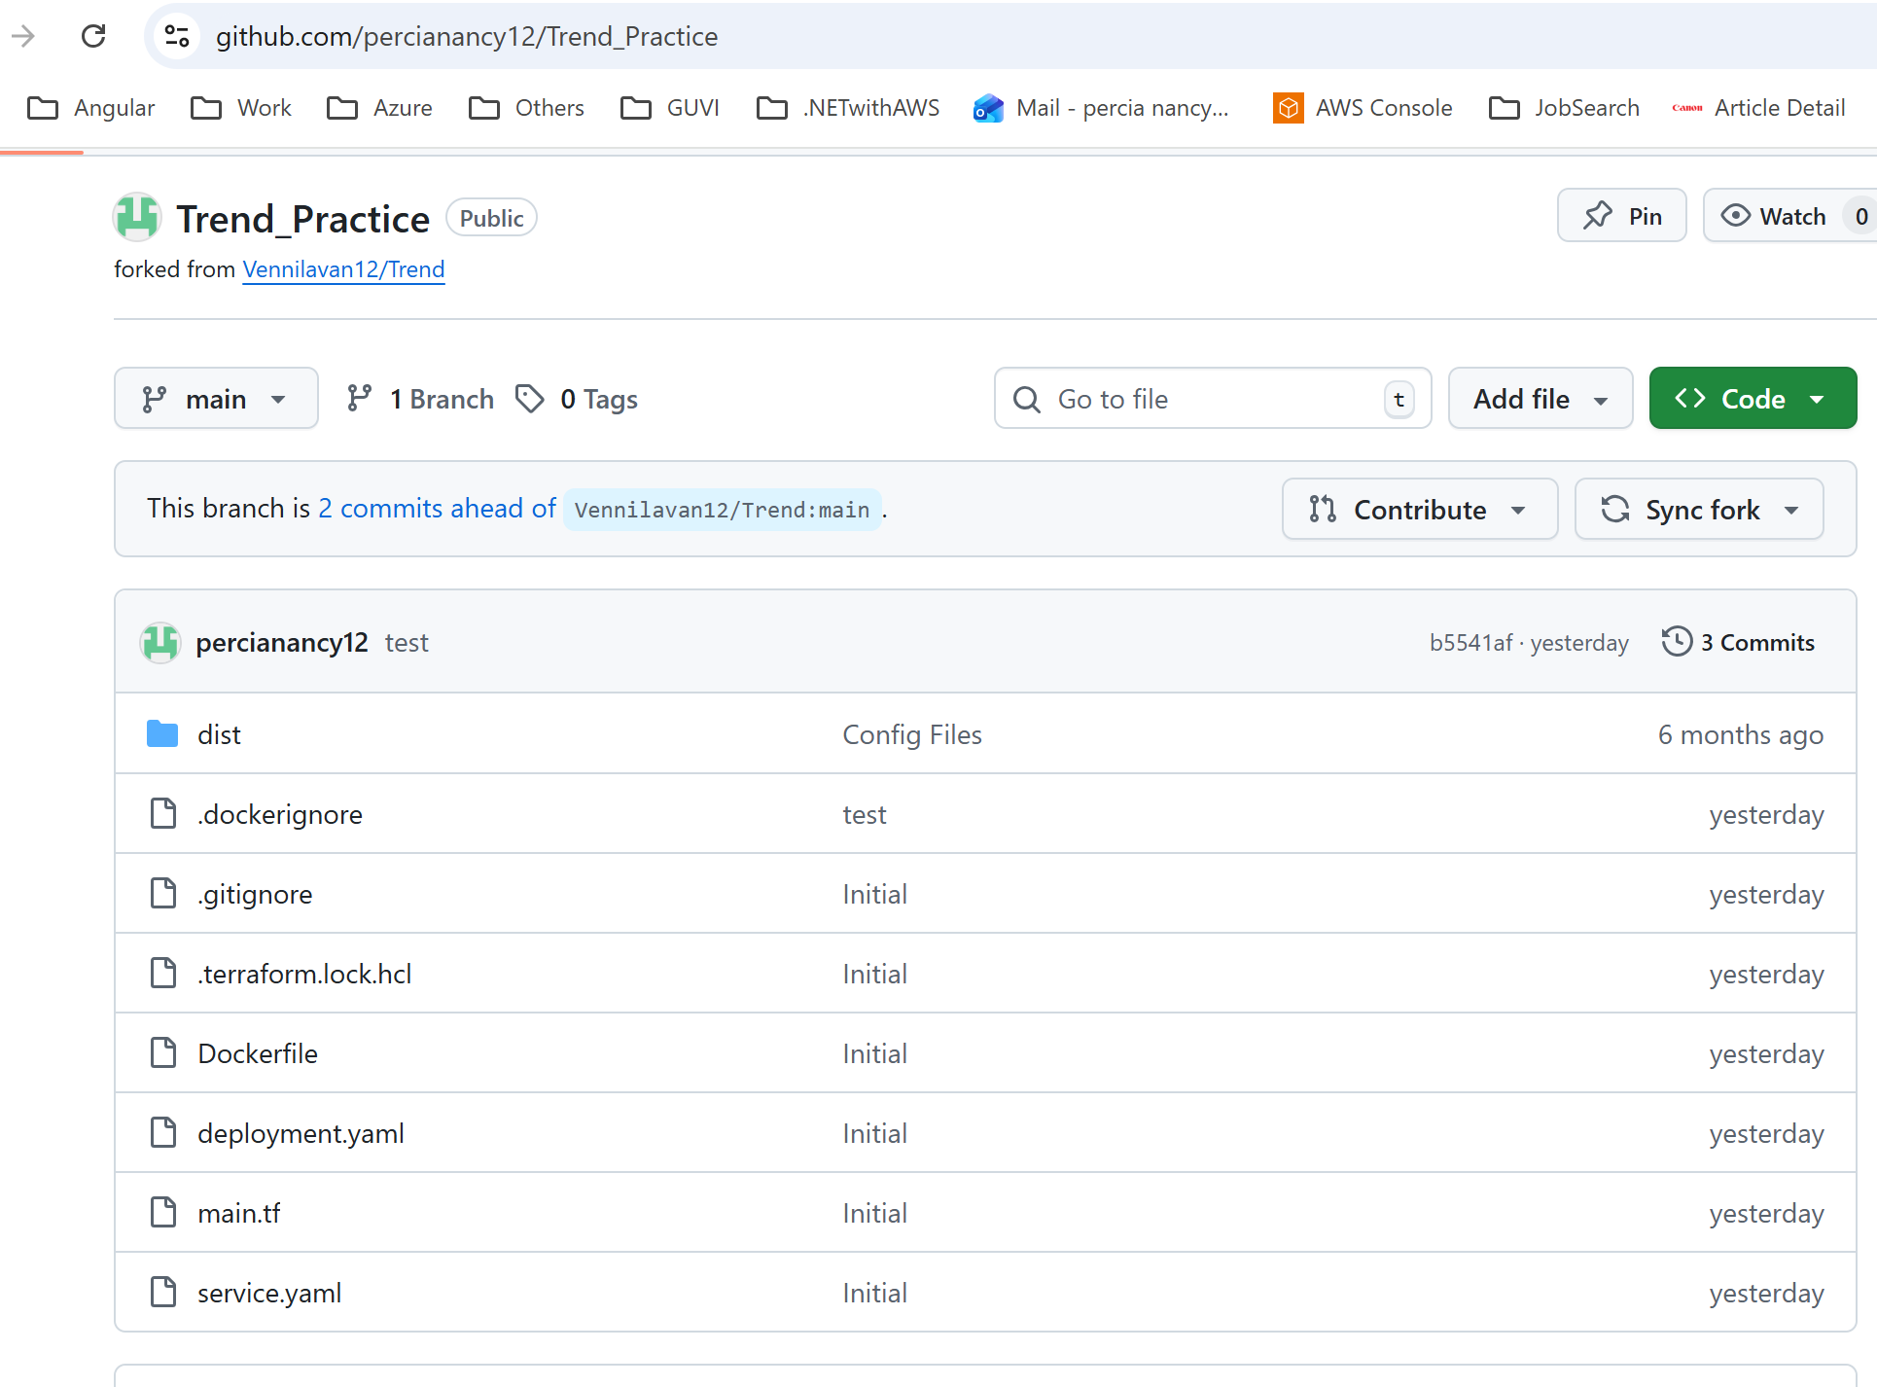
Jenkins:
Install Jenkins and necessary plugins (Docker, Git, Kubernetes, Pipeline) for build, push &deploy applications.
Setup Github and jenkins integration using github webhook build trigger for auto build for every commit.
Create a declarative pipeline script and pipeline project to build, push & deploy using CI-CD.

Steps:

- Added plugins for Docker, GIT, Kubernetes and pipeline in Jenkins
- install Docker,GIT, kubectl in EC2 server of Jenkins
- Added credentials of Docker, AWS and GIT in Jenkins
- Attach IAM policy AdministratorAccess to role ec2_jenkins_role

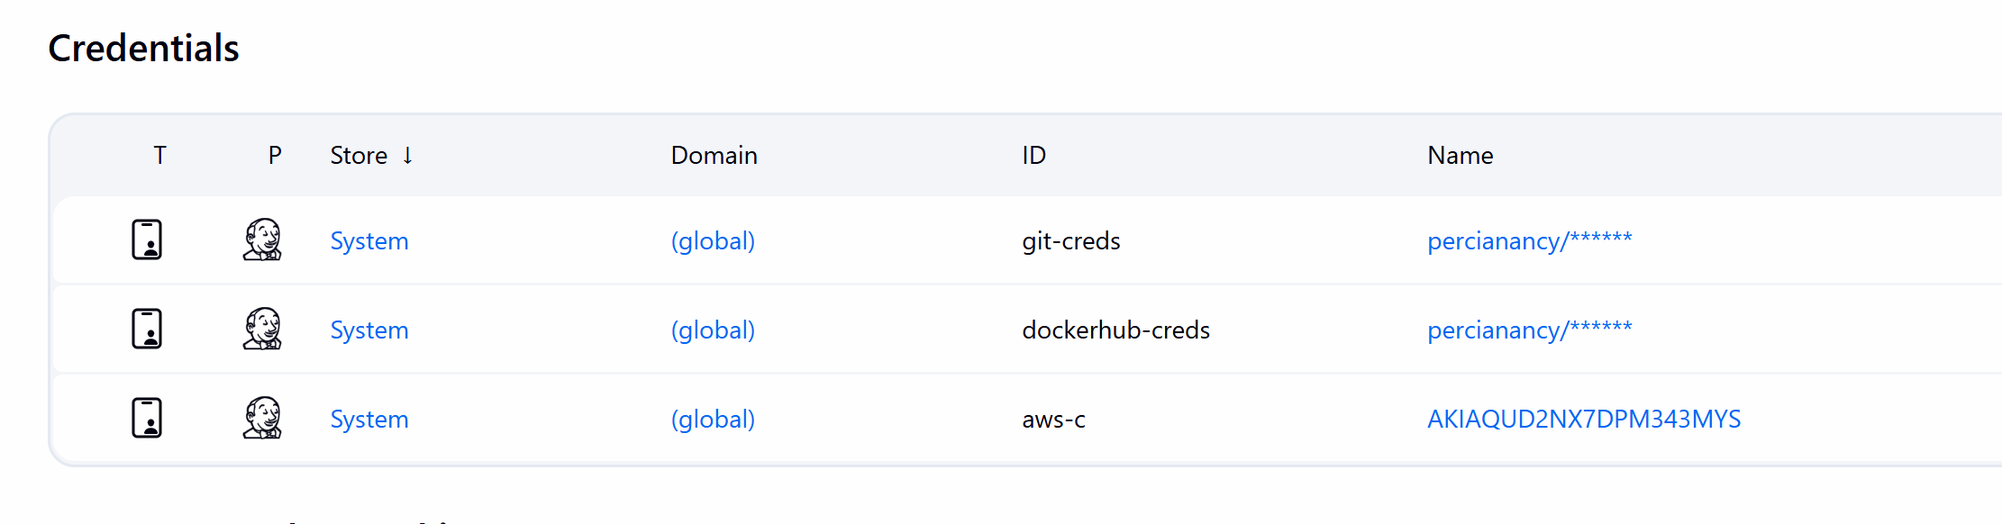
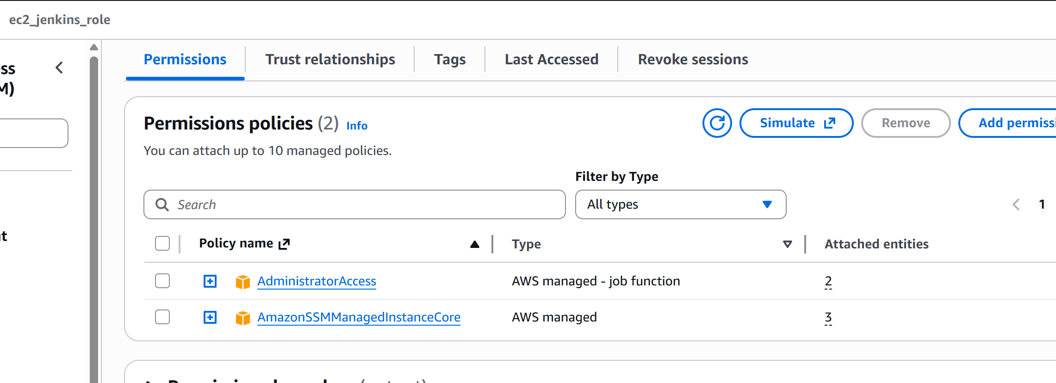
Installed Kubectl by following steps
curl "https://awscli.amazonaws.com/awscli-exe-linux-x86_64.zip" -o "awscliv2.zip"
unzip awscliv2.zip
sudo ./aws/install

/usr/local/bin/aws –version

aws configure

CLUSTER_VERSION=$(aws eks describe-cluster \
--name project2-cluster \
--region ap-south-1 \
--query "cluster.version" --output text)
curl -LO "https://dl.k8s.io/release/v${CLUSTER_VERSION}.0/bin/linux/amd64/kubectl"
chmod +x kubectl
sudo mv kubectl /usr/local/bin/

kubectl version --client

aws eks --region ap-south-1 update-kubeconfig --name project2-cluster

Create pipeline

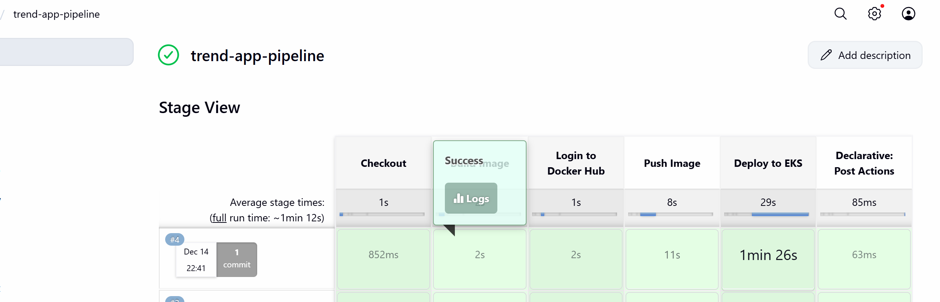

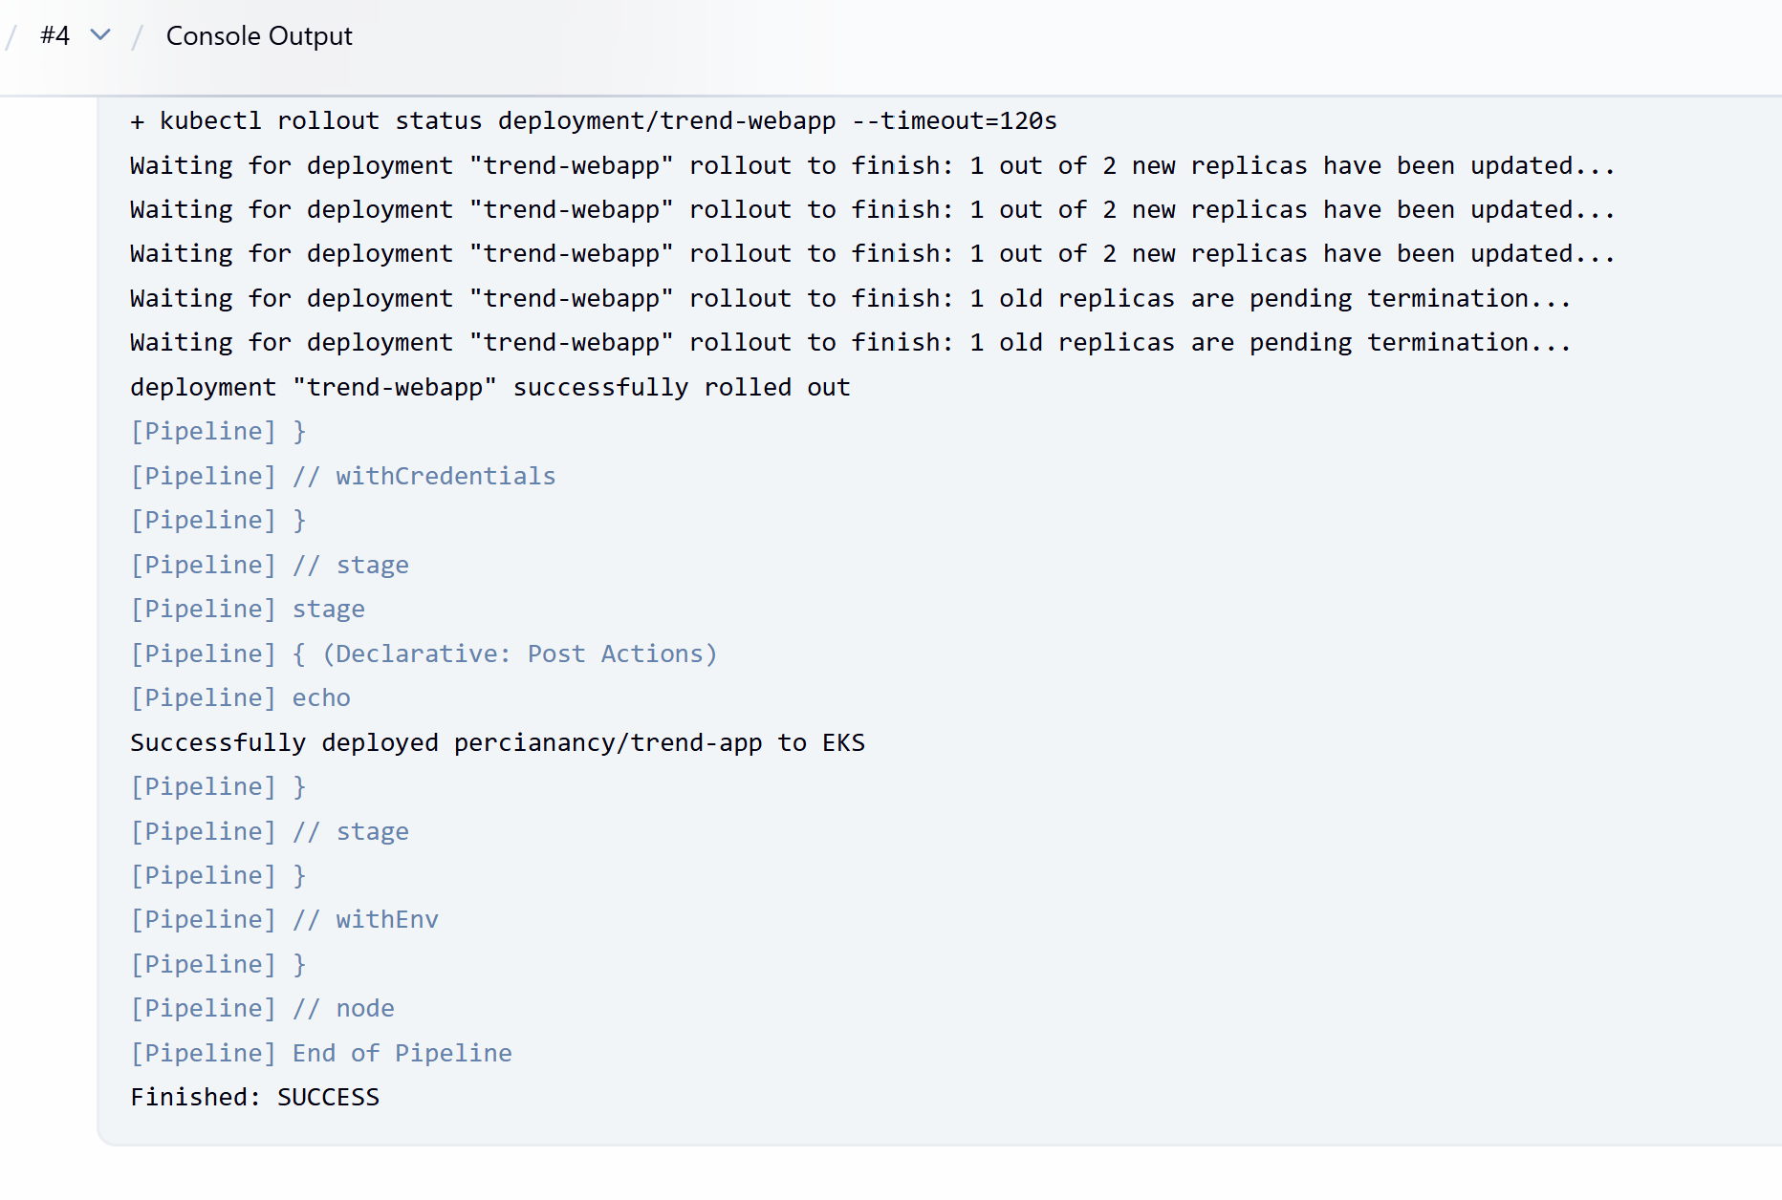
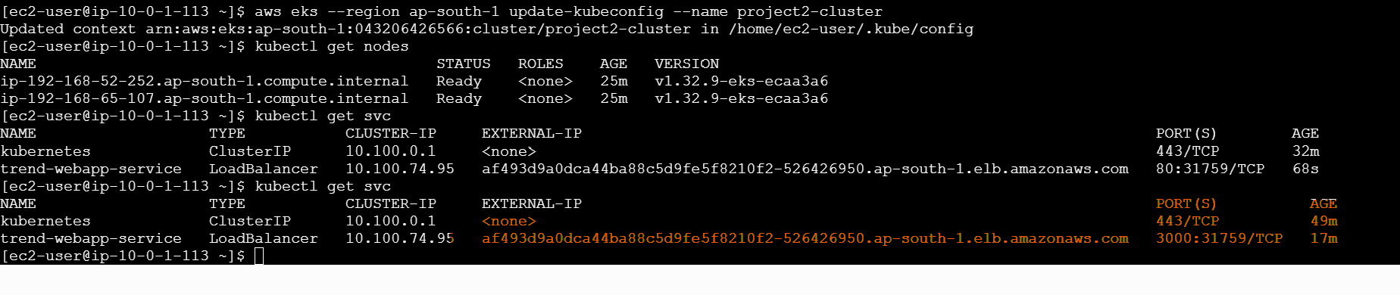

Output:



Monitoring:
- Setup a monitoring system to check the health of the cluster or application (opensource) is highly appreciable.

Install kube-prometheus-stack
helm repo add prometheus-community https://prometheus-community.github.io/helm-charts
helm repo update
helm install monitoring prometheus-community/kube-prometheus-stack -n monitoring --create-namespace
Verify pods
kubectl get pods -n monitoring
Ensure Grafana, Prometheus, Alertmanager, node-exporters, kube-state-metrics all show Running.
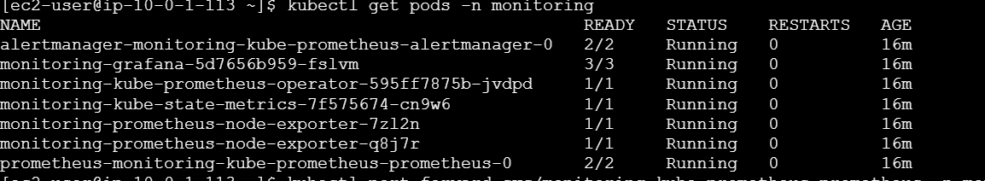

Expose services
Patch Grafana and Prometheus to LoadBalancer:
kubectl patch svc monitoring-grafana -n monitoring \
-p '{"spec": {"type": "LoadBalancer"}}'

kubectl patch svc monitoring-kube-prometheus-prometheus -n monitoring \
-p '{"spec": {"type": "LoadBalancer"}}'

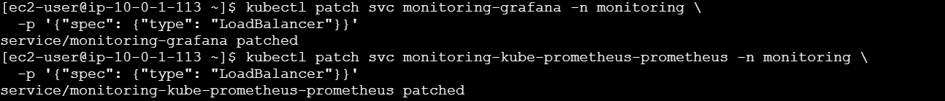

Get URLs
kubectl get svc -n monitoring
You’ll see ELB DNS names like:
- Grafana → http://<grafana-elb-dns>
- Prometheus → http://<prometheus-elb-dns>:9090
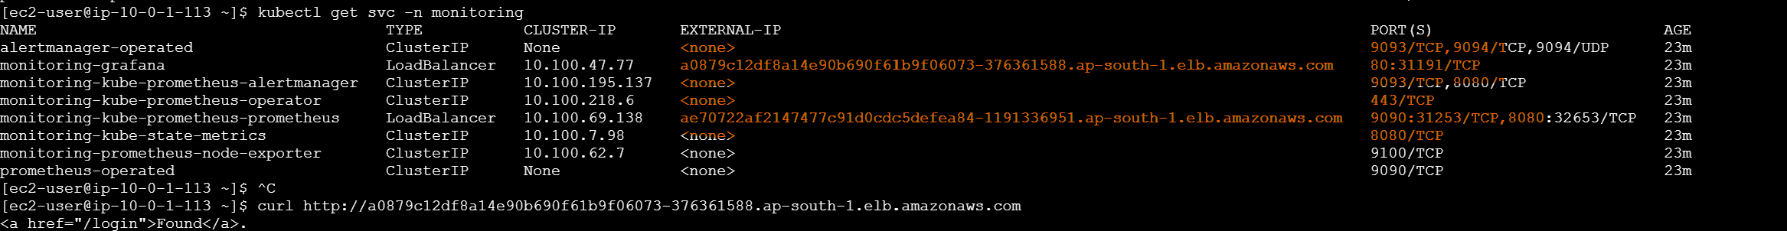
Access Grafana
- Open Grafana ELB URL in browser.
- Login:
- kubectl get secret --namespace monitoring monitoring-grafana \
- -o jsonpath="{.data.admin-password}" | base64 --decode ; echo
Username: admin
Password: decoded secret.

6. Import dashboards
In Grafana → Dashboards → Import: 6417 → Node exporter full
7. Verify Prometheus targets
Open Prometheus ELB URL → Status → Targets.
You should see:
- node-exporter
- kube-state-metrics
- kubelet
All marked UP.

